**Power BI Capstone Project Report – ShopNest Store**

**📝 Project Summary**

This capstone project analyzes key business metrics for ShopNest Store, Portugal's leading e-commerce department store. The goal is to uncover actionable insights from the provided retail datasets using Power BI.

**1. Top Categories by Total Price**

**🔹 Question Statement**

Identify the top 10 product categories generating the highest total sales revenue.

**🔹 Visualization  
  
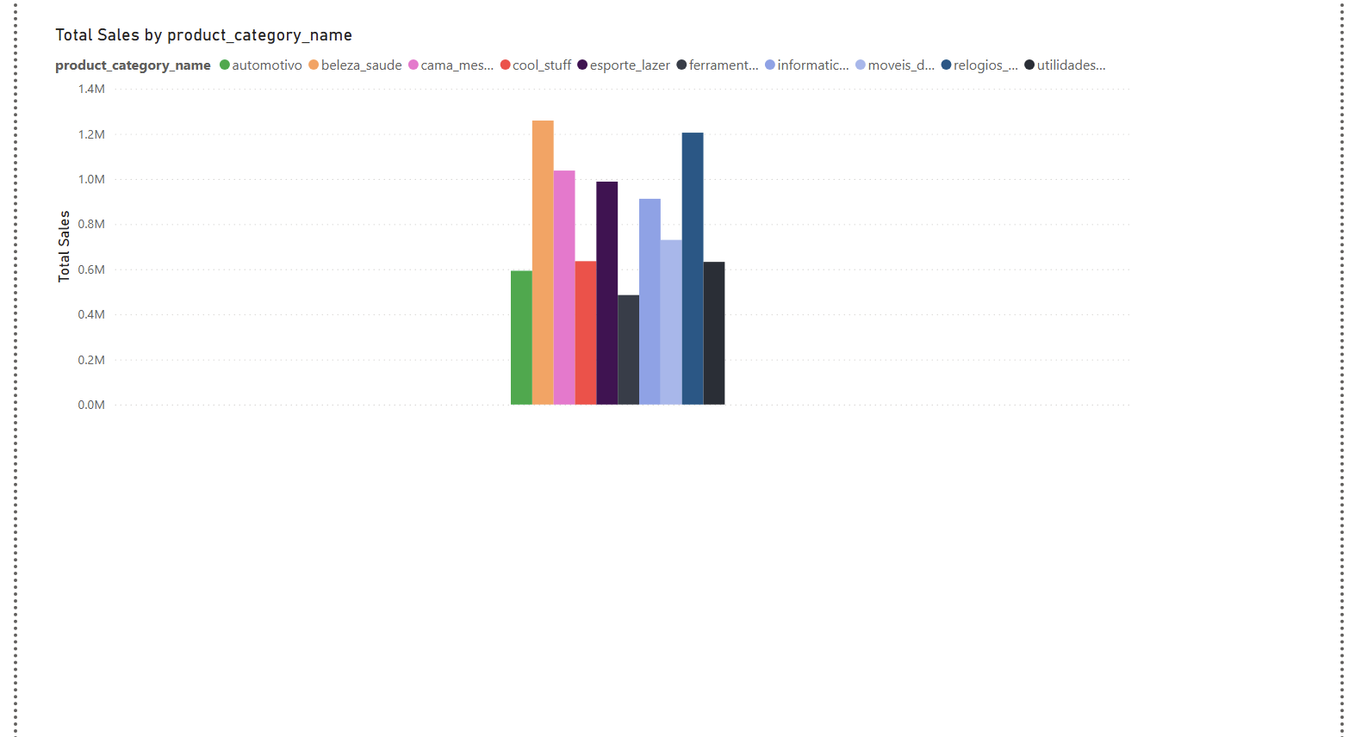**

**🔹 Explanation**

We created a DAX measure:

Total Sales = SUM(Order_Items[price])

Then used a bar chart with product category names on the axis and total sales as values. Sorting in descending order gave us the top 10 highest revenue categories. This helps focus on inventory and marketing for the best-performing segments.

**2. Delayed Orders Analysis**

**🔹 Question Statement**

Determine the number of delayed orders per product category.

**🔹 Visualization**

**🔹 Explanation**

We flagged delays using:

IsDelayed = IF(Orders[order_delivered_customer_date] > Orders[order_estimated_delivery_date], "Delayed", "On-Time")

We counted delays per category using related tables and plotted them. This shows which categories face fulfillment challenges.

**3. Monthly Comparison of Delayed and On-Time Orders**

**🔹 Question Statement**

Track delivery performance over months.

**🔹 Explanation**

A calendar table was created to group dates by month. Using counts of delayed vs. on-time orders per month, we visualized performance trends and seasonality.

**4. Payment Method Analysis**

**🔹 Question Statement**

Analyze the most frequently used payment methods.

**🔹 Visualization**

**🔹 Explanation**

A pie chart showing count of orders per payment_type from Order_Payments reveals customer preferences. Useful for payment system optimization.

**5. Product Rating Analysis**

**🔹 Question Statement**

Determine top 10 highest-rated and bottom 10 lowest-rated products.

**🔹 Visualization**

**🔹 Explanation**

We used Order_Reviews to average review scores per product. Then sorted visuals by review score ascending/descending to highlight best and worst-performing products by customer satisfaction.

**6. State-wise Sales Analysis**

**🔹 Question Statement**

Visualize total sales per customer state.

**🔹 Visualization**

**🔹 Explanation**

Joining Customers, Orders, and Order_Payments, we calculated total revenue per customer_state. This highlights high-performing regions and underperforming areas.

**7. Seasonal Sales Patterns (Quarterly)**

**🔹 Question Statement**

Analyze quarterly trends in total sales across years.

**🔹 Visualization**

**🔹 Explanation**

A calendar table allowed grouping dates by quarter. A DAX measure aggregated total sales quarterly. Visualization showed patterns in Q1–Q4 sales, revealing seasonality and campaign planning opportunities.

**8. Revenue Analysis (Yearly)**

**🔹 Question Statement**

Determine total revenue and yearly trends.

**🔹 Visualization**

**🔹 Explanation**

Using a Yearly Revenue measure with a time-based relationship from the calendar table, we plotted revenue trends across years. This supports financial tracking and business growth assessment.